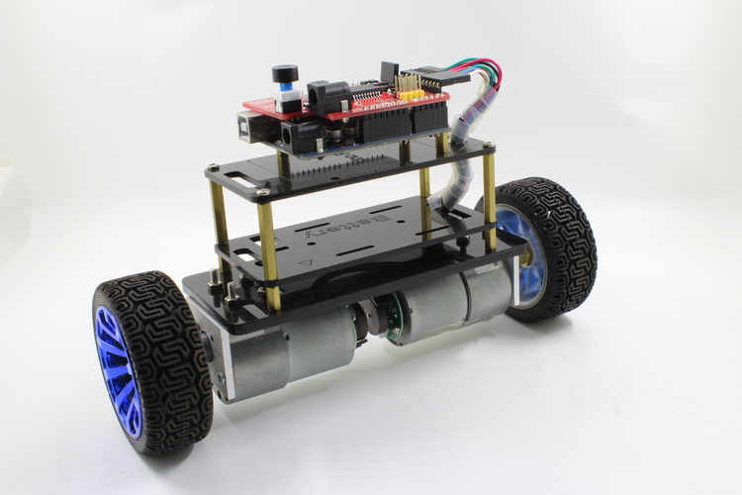

**Introductions**

The Balanbot is a Arduino Based Self-balancing Robot Kit.

The Balanbot is Open Source and easy to assemble. It uses strong acrylic structures and keeps the robot balanced using its center of gravity. In order to achieve high-performance, we tests various torque-gear motors to ensure the robot will keep balance and move flexibly even if it gets pushed suddenly.

Building the Balanbot will be so much fun for novice and experienced robotics fans!

Check for more on Indiegogo: <http://igg.me/at/balanbot>

**Features**

Easy to assemble

Controllable by Arduino UNO

Open Source Hardware and Software

High stability

High expendability

**Specs**

Working Voltage: 12~15VDC

Size (L*W*H): 21.6*6.8*13.2cm

Packaged Weight: 850g (Excluding UNO and EB modules)

Acrylic board color: Red, Black, and Transparent available

**Typical Control Demonstration**

To meet different needs, we implemented several ways to control the Balanbot. We believe the applications of Balanbot are unlimited and up to its users and their favorite devices and platforms.

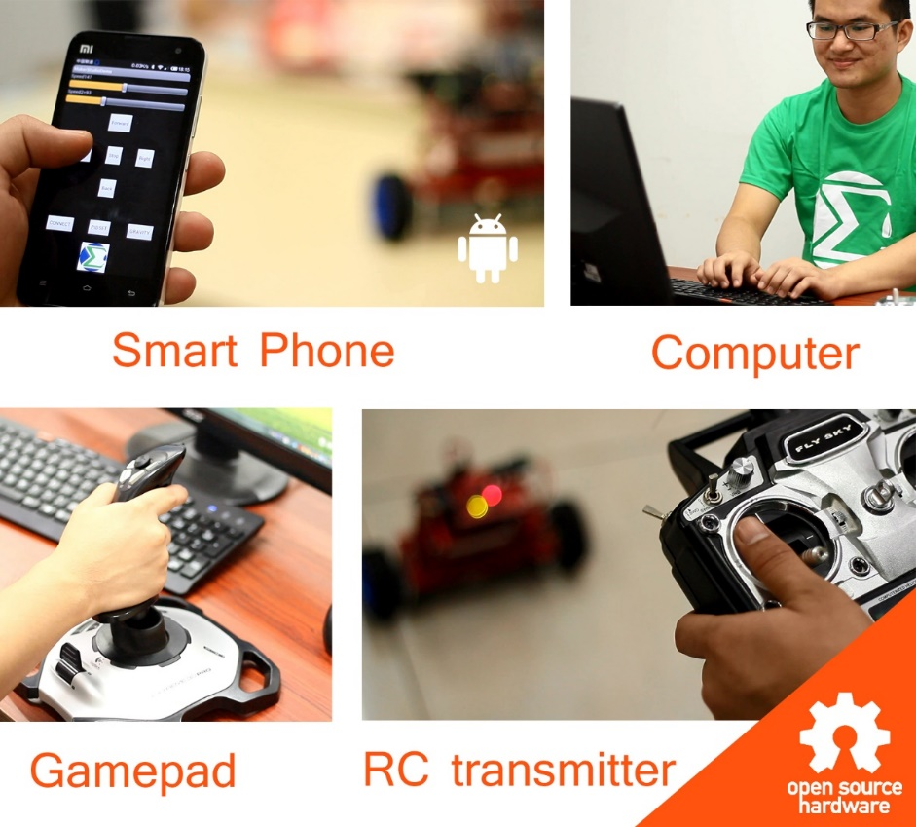

**Hardware Design**

The Balanbot includes everything you need to make your own self-balancing robot: two high torque and high speed gear motors, wheels, acrylic structures, 18650 battery holder (batteries are not included), Balance Shield, and Arduino UNO-compatible board.

The Balanbot uses one 5mm and two 3mm thick acrylic boards and other accessories for its main structure. The 5mm board is used to fix the two motors. One of the 3mm boards is used to fix the battery and the other is for an Arduino-compatible board plus the Balance Shield.

The Balanbot is super easy to assemble and play! There are no complicated connections and it is fast to put together. It is suitable for kids and experienced makers as well. Thanks to the powerful Balance shield, it is much easier now to create a balancing robot than it was before.

The Balance Shield uses an MPU6050 which is the world’s first integrated 6-axis motion-tracking device that combines a 3-axis gyroscope and a 3-axis accelerometer. It connects to the Arduino UNO compatible board through the I2C interface. With this sensor, you can get stable angle when the Kalman filter is used.

The Balance Shield also integrated one L298P for driving motors. The L298P is a high voltage (50V), high current (2A) dual channel full-bridge driver. It can drive inductive loads such as relay, DC, and stepping motors.

There are also led indicators, a power switch and a buzzer on the Balance Shield. You can even write your own code to make it play a melody.

A universal serial interface is left for connecting adapters like serial Bluetooth and serial Wi-Fi for communicating with other devices. Four IO pins are left for connecting other sensors or RC receiver for making it more extensible.

**Shipping List**

|  |  |  |  |  |
| --- | --- | --- | --- | --- |
| **Type** | **Item** | **Spec** | **Qty** |  |
| Structures | Acrylic Board | Thickness 5mm for base | 1 |  |
| Acrylic Board | Thickness 3mm for battery | 1 |  |
| Acrylic Board | Thickness 3mm for UNO | 1 |  |
| Motor Bracket | Metal | 2 |  |
| Wheels | 65mm | 2 |  |
| Even coupling | 6mm | 2 |  |
| Copper Spacer | Female to female,10mm | 6 | Add 2 more |
| Nylon Spacer | Female to female,10mm | 6 | Add 2 more |
| Copper Spacer | Female to male, 35mm+6mm | 5 | Add 1 more |
| Electronics | Gear motor | 12V, 1:43.8 | 2 |  |
| Balance Shield | For Arduino UNO | 1 |  |
| Battery holder | For 3*18650 batteries | 1 |  |
| DC connector | DC21, Male | 1 |  |
| MCU board | Makerduino UNO | 1 | Balanbot UNO Kit |
| Bluetooth 2.0 | EB-Bluetooth 2.0 | 1 | Advanced Balanbot Kit |
| Bluetooth 4.0 | EB–Bluetooth 4.0 (BLE) | 1 | Advanced Balanbot Kit |
| Wifi | EB-WiFi LBP100 | 1 | Advanced Balanbot Kit |
| Screws | Screws for motor | M3, 6mm | 8 |  |
| Screws for even coupling | M3, 6mm | 4 | Add 2 more |
| Screws for wheels | M4, 6mm | 2 |  |
| Screws for battery holder | M3, 8mm | 4 |  |
| Nut | M3 | 15 | Add 5 more |
| Screws | M3, 6mm | 12 | Add 4 more |
| Screws | M3, 8mm | 12 | Add 4 more |
| Screws | M3, 12mm | 12 | Add 4 more |
| Accessories | Bobbin | Diameter 6mm,length 10cm | 1 |  |
| Cable ties | >200mm | 4 |  |
| Screwdriver | Straight screwdriver | 1 |  |